‘Silent’ Installer script

The purpose of this installer is to make the upgrade process easier for offices to get on the latest version of the software. We are currently pushing for Titanium upgrades, but if the upgrade process for DEXIS is too daunting for the office, it reduces the number of upgrades, and increases the number of Platinum Sensors in the field.

The script utilizes the built-in functionality for the Install Shield install wizard—the current installer for our products. Running the installer in ‘record’ mode generates a text file that records all the options that the user manually inputs into the installer (Accepting the End User License Agreement, Selecting the install path, selecting the server path, etc. Running the installer in ‘silent’ mode utilizes the generated file to process the options that were previously selected.

The generated file is a text file. The path can be modified to meet the specific client server path.

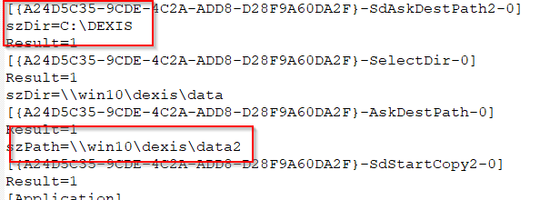

The 2 highlighted sections are the values that can be changed to set the path of the local install, and the server install.

The Ideal scenario:

* Install DEXIS on the server using DEXmenu. This will generate the latest da948US.exe and the DEX-LibPlatinum.exe.
* Use the script on a single workstation in ‘record’ mode. The path below is to be set to the UNC path of the server\download folder.  
  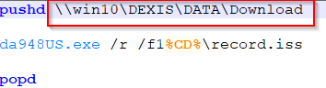
* After running it in record mode for a single workstation. The record.iss file is generated.
* On all other workstations, run script in ‘silent’ mode. (The path in the ‘silent’ script needs to be set to the same path in the ‘record’ script
* The program will then install utilizing the record.iss file. The command prompt will sit at a blinking cursor for about 5 minutes while the software installs in the background.

Install Shield ‘record’ mode requires a drive letter to access the record.iss file. To bypass this, I utilized the pushd function in windows to push a unc path to a Drive. pushd will then take the unc path, turn it into a mapped drive with the lowest available letter, and set that as the current location. The %CD% will replicate the current path. For example:  
pushd \\server\dexis\data will set Z:\data\download as the current path.  
then running %CD%\record.iss is the same as z:\data\download\record.iss. This is to accommodate the multitude of office setups do I don’t have to hard code the path of the record file.  
After the install function finishes, running popd will “pop” off the drive, disconnecting the mapped network location so no drive is leftover.